24MIS0015
KRITHIKA SHREE.K
8-10-26

MAVEN PROJECT:

pom.xml:

<project xmlns="http://maven.apache.org/POM/4.0.0"
xmlns:xsi="http://www.w3.org/2001/XMLSchema-instance"
xsi:schemaLocation="http://maven.apache.org/POM/4.0.0
http://maven.apache.org/xsd/maven-4.0.0.xsd">

<modelVersion>4.0.0</modelVersion>

<groupId>com.example</groupId>
<artifactId>my_maven_project</artifactId>
<version>1.0-SNAPSHOT</version>

<build>
<plugins>
<plugin>
<groupId>org.apache.maven.plugins</groupId>
<artifactId>maven-compiler-plugin</artifactId>
<version>3.8.1</version>
<configuration>
<source>1.8</source>
<target>1.8</target>
</configuration>
</plugin>
</plugins>
</build>

</project>

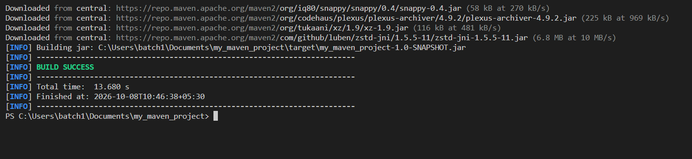

PROJECT FOLDER:

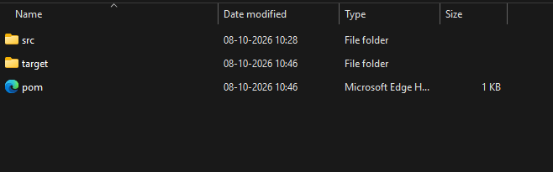
push to git:
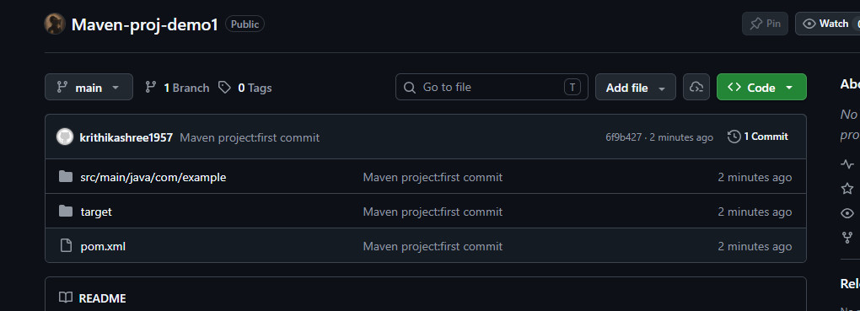
configure maven:
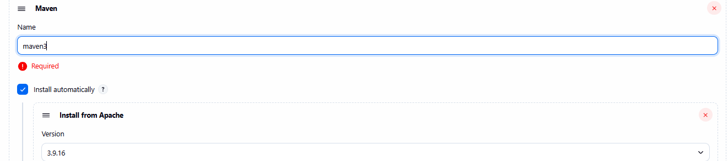

jenkins configure:

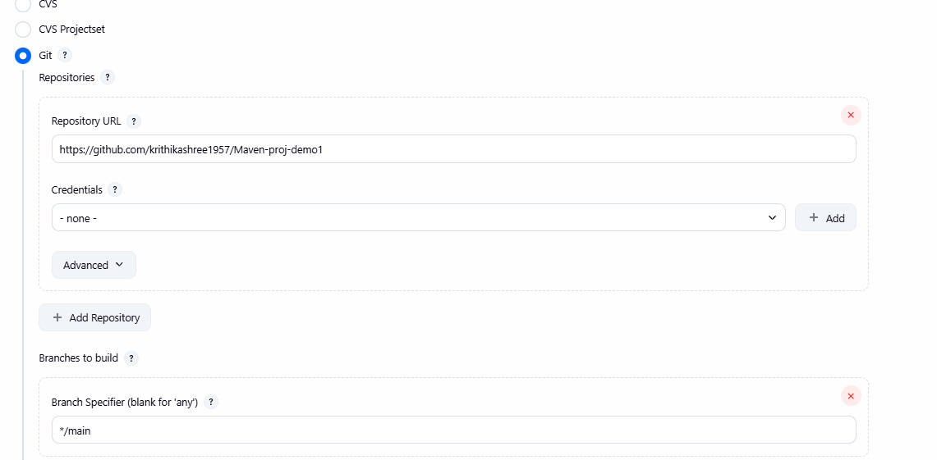

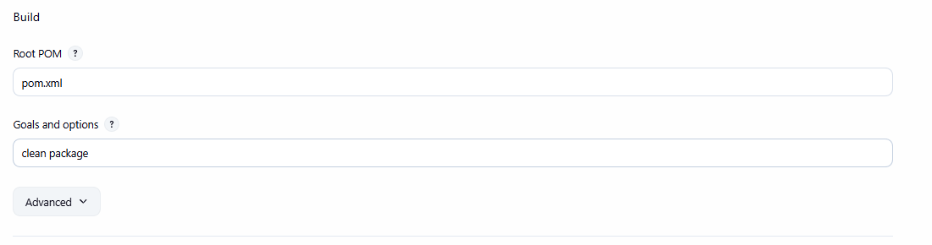

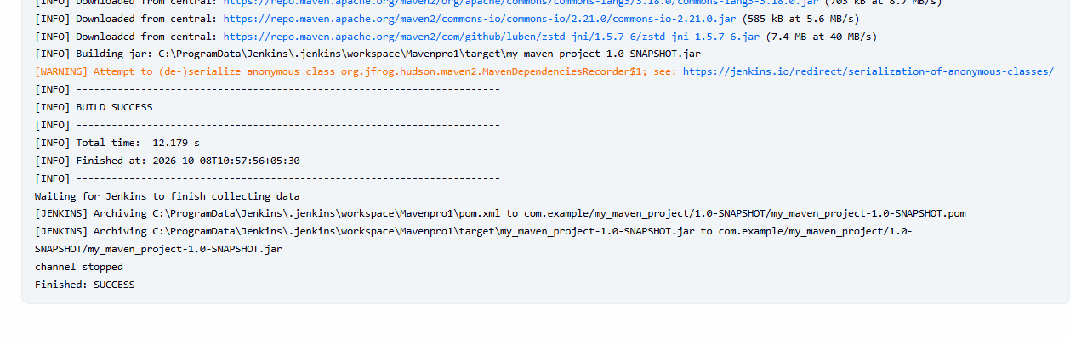
Build successful:

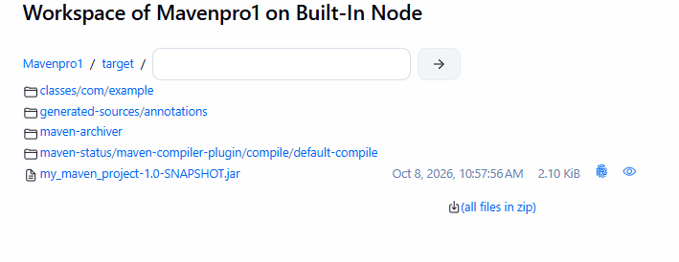
JAR FILE CREATED:

